**CN Lab 09**

**MOHAMMAD BASIL ALI KHAN**

**20K-0477**

**Question#01:**

Network 1: 10.20.0.0 /27 Host range: 10.20.0.1 to 10.20.0.31

Network 2: 10.20.0.32 /27 Host range: 10.20.0.33 to 10.20.0.63

Network 3: 10.20.0.64 /27 Host range: 10.20.65 to 10.20.0.91

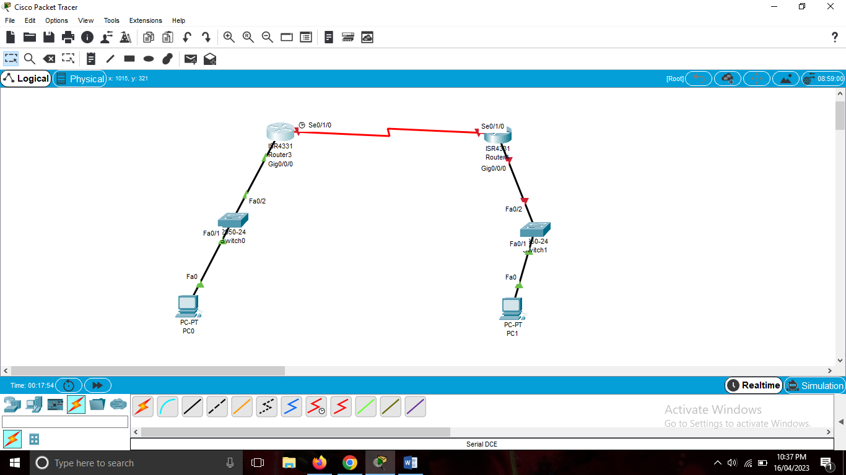

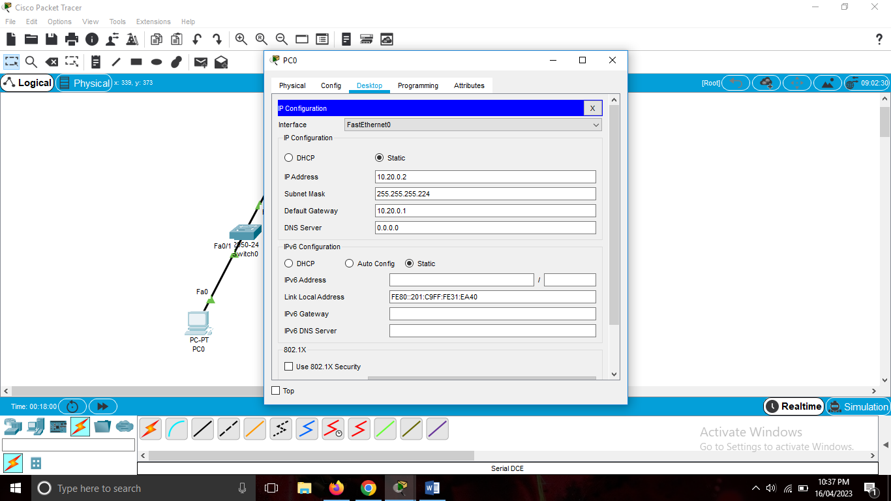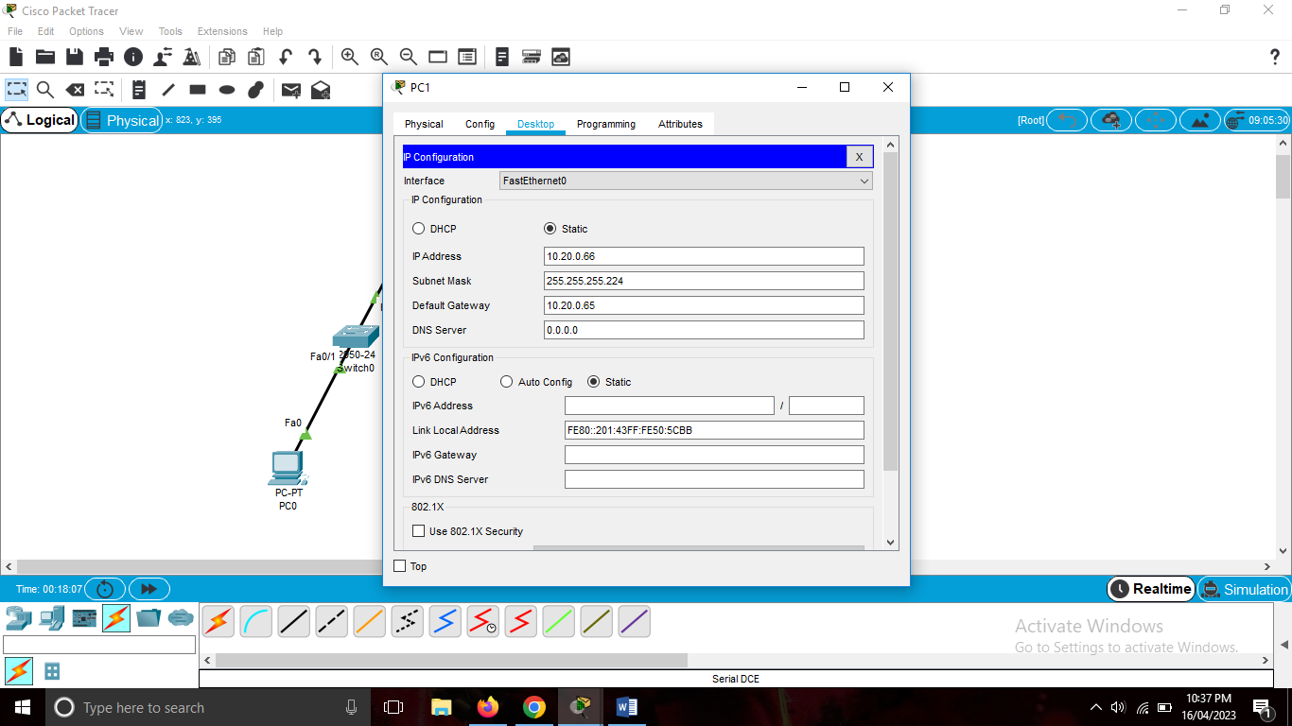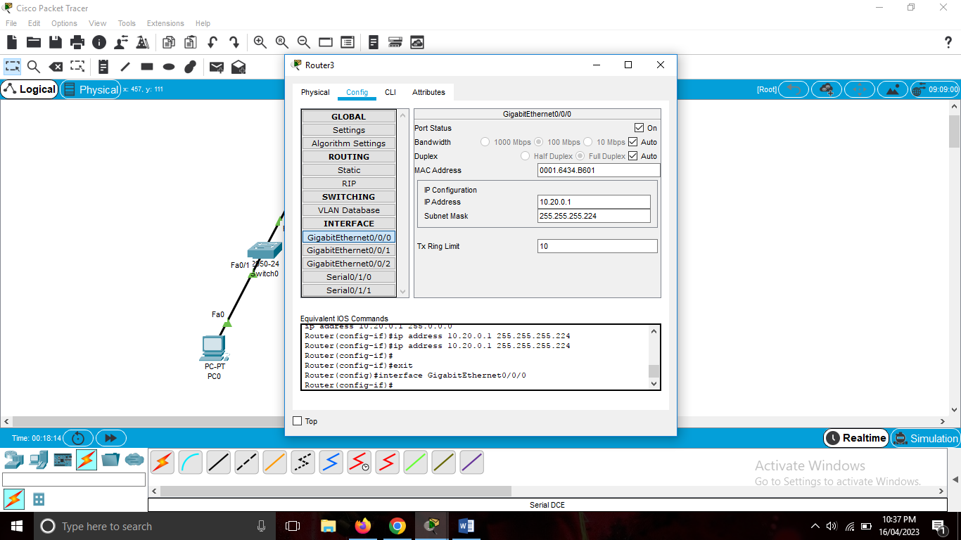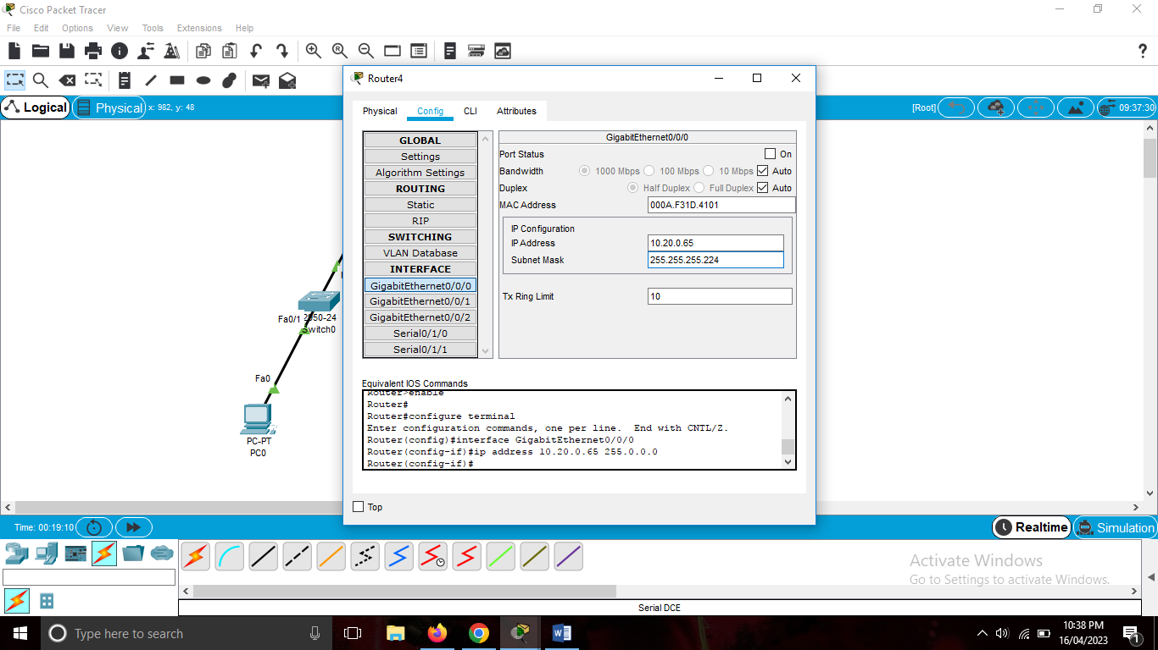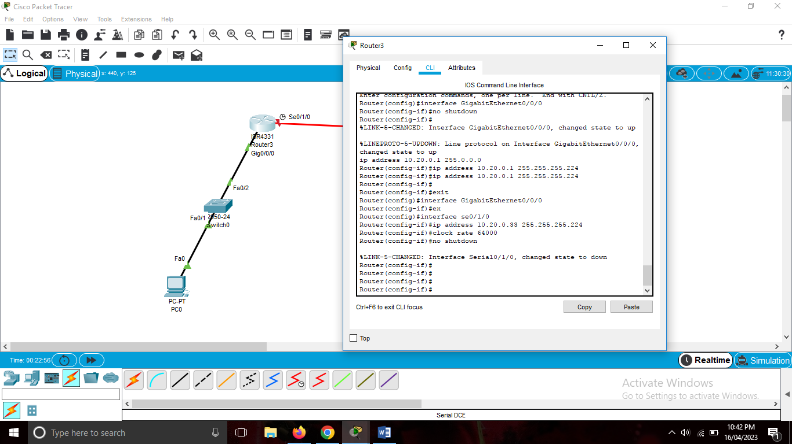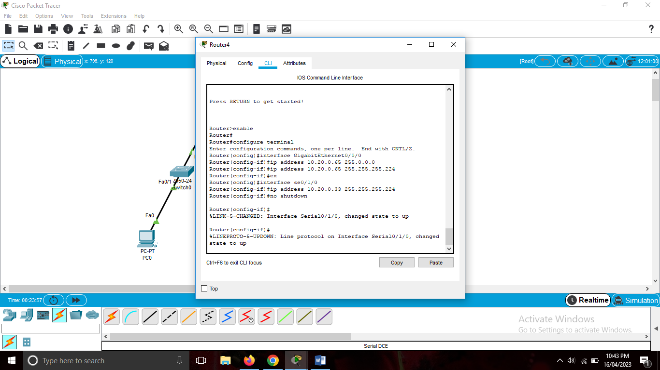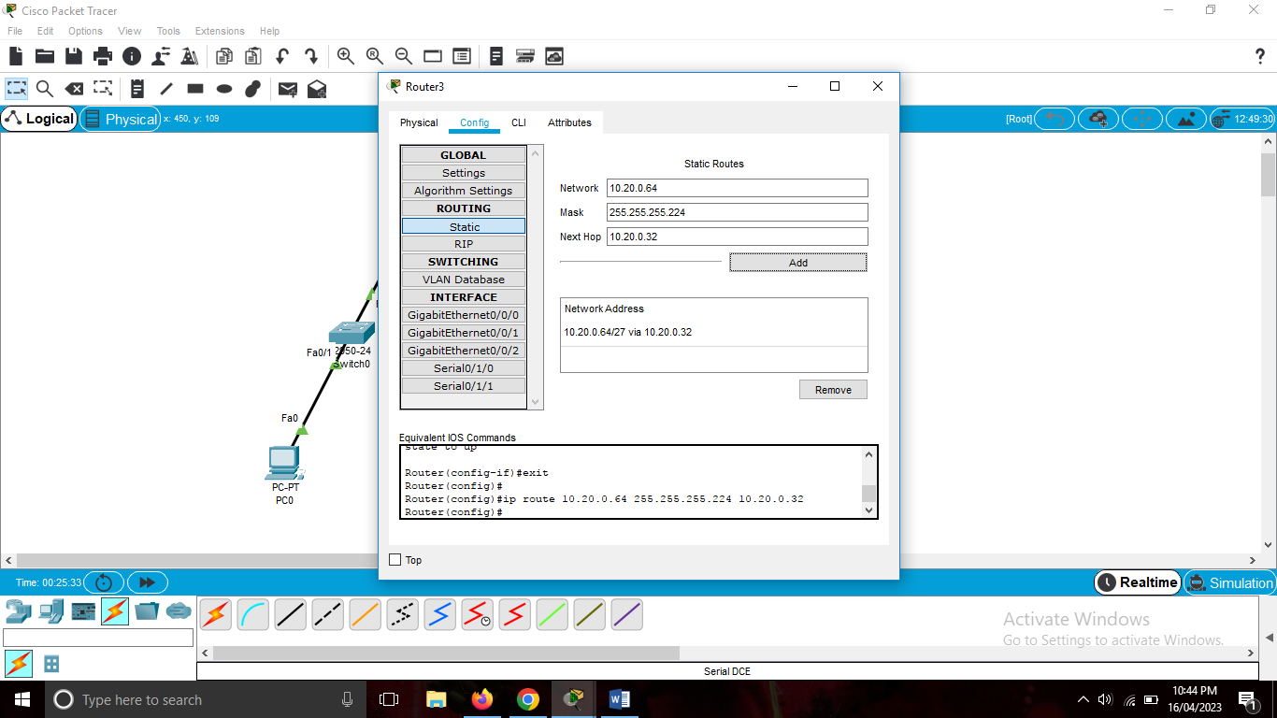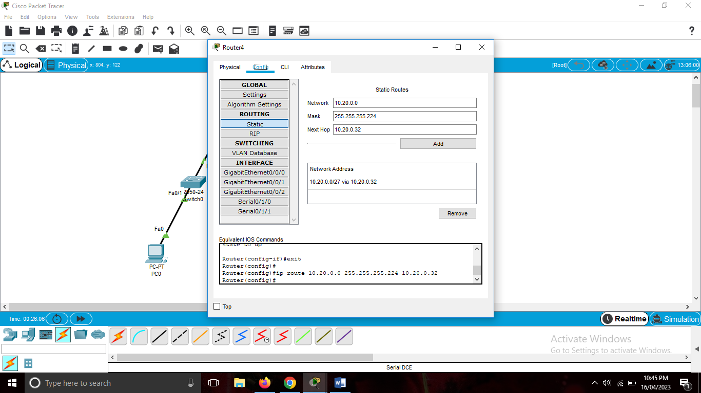

**Question#02:**

Network address: 200.16.100.0/24

Possible hosts: 32 – 24 = 8 bits

Dev Department: 120 PCs

Available hosts: 2^7 – 2 = 126

32 – 7 =25

Network address: 200.16.100.0/25

Subnets: 2^1 = 2

Subnet mask: 255.255.255.128

Broadcast address: 200.16.100.127

Range: 200.16.100.1 – 200.16.100.126

Finance Department: 35 PCs

Available hosts: 2^6 – 2 = 62

32 – 6 = 26

Network address: 200.16.100.128/26

Subnets: 2^2 = 4

128 + 64 = 192

Subnet mask: 255.255.255.192

Broadcast address: 200.16.100.191

Range: 200.16.100.129 – 200.16.100.190

HR Department: 10 PCs

Available hosts: 2^4 – 2 = 14

32 – 4 = 28

Network address: 200.16.100.192/28

Subnets: 2^4 = 16

128 + 64 + 32 + 16 = 240

Subnet mask: 255.255.255.240

Broadcast address: 200.16.100.207

Range: 200.16.100.193 – 200.16.100.206

**Question#03:**

Network 1: 90 PCs for CS

Available host: 2^7 - 2 = 128 - 2 = 126

Network address: 195.168.10.0/25

32 - 7 = 25

Subnets: 2^1 = 2

Subnet Mask: 255.255.255.128

Broadcast address: 195.168.10.127

Range: 195.168.10.1 – 195.168.10.126

Network 2: 50 PCs for EE

Available host: 2^6 = 64 - 2 = 62

Networks Address: 195.168.10.128 /26

32 - 6 = 26

Subnets: 2^2 = 4

128 + 64 =192

Subnet Mask: 255.255.255.192

Broadcast Address: 195.168.10.191

Range: 195.168.10.129 – 195.168.10.190

Network 3: 20 PCs for BBA

Available host: 2^5 = 32 - 2 = 30

Networks Address: 195.168.10.192/27

32 - 5 = 27

Subnets: 2^2 = 4

128 + 64 + 32 = 224

Subnet Mask: 255.255.255.224

Broadcast Address: 200.19.100.223

Range: 200.16.100.193 – 200.16.100.222

Network 4:

Available host: 2^4 = 16 - 2 = 14

Networks Address: 195.168.10.224 /28

32 - 4 = 28

Subnets: 2^2 = 4

128 + 64 + 32 +16 = 240

Subnet Mask: 255.255.255.240

Broadcast Address: 200.19.100.239

Range: 200.16.100.225 – 200.16.100.238

Network 5:

Available host: 2^3 = 8 - 2 = 6

Networks Address: 195.168.10.240 /29

32 - 3 = 29

Subnets: 2^2 = 4

128 + 64 + 32 +16 + 8= 248

Subnet Mask: 255.255.255.248

Broadcast Address: 200.19.100.247

Range: 200.16.100.241 – 200.16.100.246

